OS Lab #3

Question 1

/*
C Program to block a parent process, until
the child completes using a wait system call
*/

// imports
#include <stdio.h>
#include <stdlib.h>
#include <sys/types.h>
#include <sys/wait.h>
#include <unistd.h>

int main() {
// creating child and parent process
// storing process id in `r_val`
printf("[*] Starting parent process\n");
int r_val = fork();

// switching between different processes
switch(r_val) {

// in case some error occurs in creation
case -1: {
perror("[*] fork\n");
exit(EXIT_FAILURE);
}
break;

// in case of child process
case 0: {
printf("[**] Inside child process\n");

// Sleeping...
for(int i = 0; i < 10; i++) {
sleep(1);
printf("[**] Sleeping child for %d seconds...\n", i + 1);
}

// exiting from the child program
exit(0);
}
break;

// in case of parent class
default: {
printf("[*] Waiting for child\n");

// waiting for child process to finish executing
wait(NULL);
printf("[*] Child process finished execution\n");

// exiting from the parent program
exit(0);
}
}
}

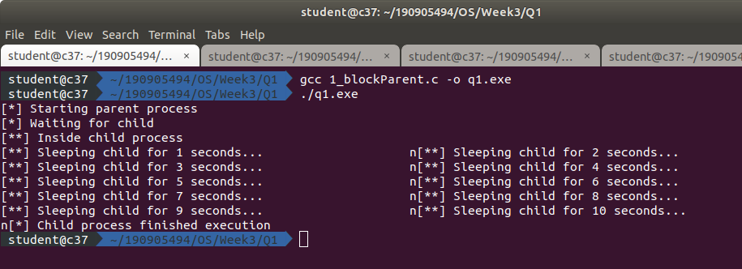

Question 2

/*
Program to load binary executables of the previous program,
in a child process using `exec` system call
*/

// imports
#include <stdio.h>
#include <stdlib.h>
#include <sys/types.h>
#include <sys/wait.h>
#include <unistd.h>

int main() {
// creating child and parent process
// storing process id in `r_val`
printf("[*] Starting parent process\n");
int r_val = fork();

// switching between different processes
switch(r_val) {

// in case some error occurs in creation
case -1: {
perror("[*] fork\n");
exit(EXIT_FAILURE);
}
break;

// in case of child process
case 0: {
printf("[**] Inside child process\n");
printf("[**] Executing ./q1 inside child\n");

// executing the output of the `1_blockParents.c` file
execl("../Q1/q1.exe", "./q1.exe" , NULL);

// exiting from the child program
exit(0);
}
break;

// in case of parent class
default: {
printf("[*] Waiting for child\n");

// waiting for child process to finish executing
wait(NULL);
printf("[*] Child process finished execution\n");

// exiting from the parent program
exit(0);
}
}
}

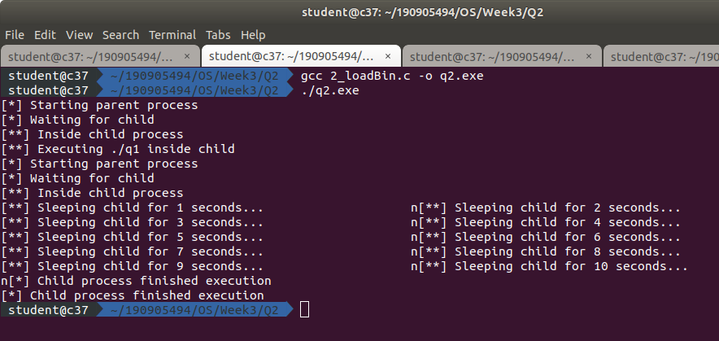

Question 3

/*
Program to create a child process.
Display the process IDs of the process,
parent and child(s) in both the
parent and child process.
*/

// imports
#include <stdio.h>
#include <stdlib.h>
#include <sys/types.h>
#include <sys/wait.h>
#include <unistd.h>

int main() {
// creating child and parent process
// storing process id in `r_val`
printf("[*] Starting parent process\n");
int r_val = fork();

// switching between different processes
switch(r_val) {

// in case some error occurs in creation
case -1: {
perror("[*] fork\n");
exit(EXIT_FAILURE);
}
break;

// in case of child process
case 0: {
printf("[**] Inside child process\n");

// getting and printing PID
pid_t curr_pid = getpid();
printf("[**] PID of child process: %d\n", curr_pid);

// exiting from the parent program
exit(0);
}
break;

// in case of parent class
default: {
// getting and printing PID
pid_t curr_pid = getpid();
printf("[*] PID of parent process: %d\n", curr_pid);

// waiting for child process to finish executing
printf("[*] Waiting for child\n");
wait(NULL);
printf("[*] Child process finished execution\n");

// exiting from the parent program
exit(0);
}
}
}

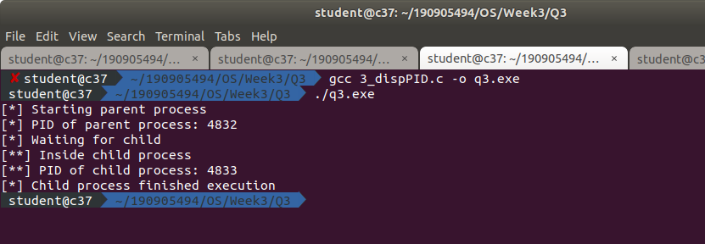

Question 4

/*
Create a zombie hild process,
and allow the init process to adopt it.
Run the process as a background process
and run the "ps" command
*/

// imports
#include <stdio.h>
#include <stdlib.h>
#include <sys/types.h>
#include <sys/wait.h>
#include <unistd.h>

int main() {

// creating child and parent process
// storing process id in `r_val`
printf("[*] Starting parent process\n");
int r_val = fork();

// switching between different processes
switch(r_val) {

// in case some error occurs in creation
case -1: {
perror("[*] fork\n");
exit(EXIT_FAILURE);
}
break;

// in case of child process
case 0: {
printf("[**] Inside child process\n");

// getting and printing PID
pid_t curr_ppid = getppid();
printf("[**] Current parent: %d\n", curr_ppid);

// Sleeping...
for(int i = 0; i < 10; i++) {
sleep(1);
printf("[**] Sleeping child for %d seconds...\n", i + 1);
}

// getting and printing PID
curr_ppid = getppid();
printf("[**] Current parent: %d\n", curr_ppid);

// exiting from the child program
exit(0);
}
break;

// in case of parent class
default: {
// showing the current running process
printf("[**] Executing ps\n");
execl("/bin/ps", "ps", NULL);

// exiting from the parent program
exit(0);
}
}
}

